**Differentiation and Integration Formulas**

The **Differential Calculus**splits up an area into small parts to calculate the rate of change. The **Integral**

**calculus**joins small parts to calculates the area or volume and in short, is the method of reasoning or calculation.

**Differential Calculus Formulas:**

Differentiation is a process of finding the derivative of a function. The derivative of a function is defined as y = f(x)

of a variable x, which is the measure of the rate of change of a variable y changes with respect to the change of

variable x.

These rules make the differentiation process easier for different functions such as trigonometric functions,

logarithmic functions, etc. Here, a list of differential calculus formulas is given below:

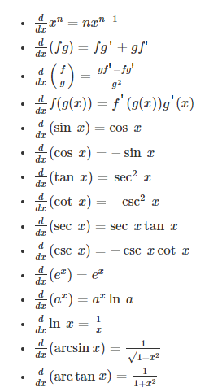

**Integral Calculus Formulas**

Integration is the process of continuous addition and the variable “C” represents the constant of integration. Also, it

helps to find the area under the curve of a function. There are certain important integral calculus formulas helps to

get the solutions. The list of integral calculus formulas is given below:

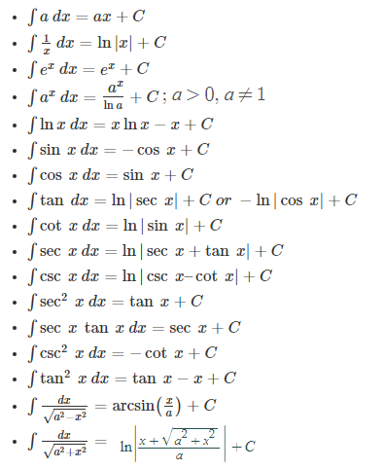

**Trigonometry Formulas**

All the formulas of trigonometry chapter are provided here for students to help them solve problems quickly.

sin(−θ) = −sin θ

cos(−θ) = cos θ

tan(−θ) = −tan θ

cosec(−θ) = −cosecθ

sec(−θ) = sec θ

cot(−θ) = −cot θ

**Product to Sum Formulas**

sin x sin y = 1/2 [cos(x–y) − cos(x+y)]

cos x cos y = 1/2[cos(x–y) + cos(x+y)]

sin x cos y = 1/2[sin(x+y) + sin(x−y)]

cos x sin y = 1/2[sin(x+y) – sin(x−y)]

**Sum to Product Formulas**

sin x + sin y = 2 sin [(x+y)/2] cos [(x-y)/2]

sin x – sin y = 2 cos [(x+y)/2] sin [(x-y)/2]

cos x + cos y = 2 cos [(x+y)/2] cos [(x-y)/2]

cos x – cos y = -2 sin [(x+y)/2] sin [(x-y)/2]

**Identities**

sin2 A + cos2 A = 1

1+tan2 A = sec2A

1+cot2 A = cosec2 A

**Basic Trigonometric Formulas**

cos (A + B) = cos A cos B – sin A sin B

cos (A – B) = cos A cos B + sin A sin B

sin (A+B) = sin A cos B + cos A sin B

sin (A -B) = sin A cos B – cos A sin B

tan(A+B) = [(tan A + tan B)/(1 – tan A tan B)]

tan(A-B) = [(tan A – tan B)/(1 + tan A tan B)]

cot(A+B) = [(cot A cot B − 1)/(cot B + cot A)]

cot(A-B) = [(cot A cot B + 1)/(cot B – cot A)]

sin2A = 2sinA cosA = [2tan A /(1+tan2A)]

cos2A = cos2A–sin2A = 1–2sin2A = 2cos2A–1= [(1-tan2A)/(1+tan2A)]

tan 2A = (2 tan A)/(1-tan2A)

sin3A = 3sinA – 4sin3A

cos3A = 4cos3A – 3cosA

tan3A = [3tanA–tan3A]/[1−3tan2A]

Video Link: <https://www.youtube.com/watch?v=VIi_gj9CHR8>

Web Link: [Formulas](http://www.pas.rochester.edu/~arijit/c02.pdf)